Till Platform

Project Description Document

Project developed by:

Bruno Faria Almeida (Nick7OlFox)

1. **Table of Contents**

2. Design Decision

2.1 Colour Palette

2.2 Text Font and Size

2.3 Conceptual Design

3. Class Design

3.1 Item Class

**2. Design Decision**

**2.1 Colour Palette**

The program will be designed around a colour palette consisting of five different colours. The colours selected are:

|  |  |  |
| --- | --- | --- |
| Colour | Hexadecimal code | Purpose |
|  | #0A0908 | To be used on the background of the application |
|  | #22333B | To be used on the background of textboxes |
|  | #F2F4F3 | To be used on text displayed on textboxes |
|  | #5E503F | To be used on the background of buttons |
|  | #A9927D | To be used on text displayed on buttons |

The selection of this colour palled was done with the following criteria:

* Provide a generally neutral visual style to the application;
* Have two sets of similar and contrasting colours to improve readability;
* Be an accessible colour palette to all types of colour-blindness;

**2.2 Text Font and Size**

All of the text on the app should be in the *Segoe UI* font. This font was selected due to its simplicity to improve readability.

All of the text on the app should be displayed at a big enough size to allow for easy readability. Non crucial information, such as, but not limited to, the current date and time, and the till number.

To reinforce important information, the use of **bold** text is encouraged.

**2.3 Conceptual Design**

Below is a conceptual representation of the idea for the UI. While general principles like colour palette and font and size of text are to remain the same, the actual layout will depend on the function implemented on each build of the App.

While the present representation shows numerous buttons with functions the user can use, these buttons might be hidden in the actual App, depending on what the user is currently doing. For example, while the user is scanning the items, the buttons to indicate how the payment will be executed (four buttons on the bottom right corner) will be hidden, only to be displayed when the user presses Get Total, at which point the other buttons would be hidden.

It is important to reiterate that the following is merely a mock-up of the GUI and it’s subject to change, which if decided, should be noted on this document.

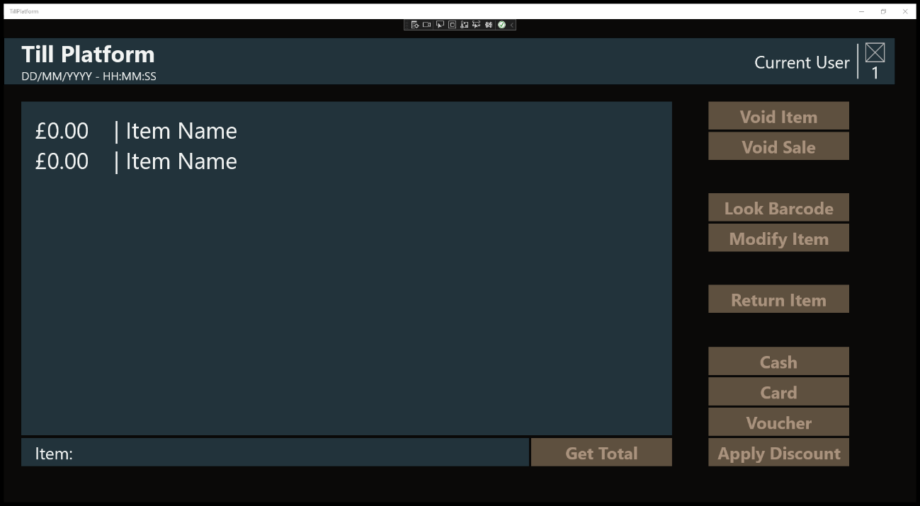

**3. Class Design**

**3.1 Item Class**

The item class is responsible for representing an item through code. This class will be used to better manage the items added to the current sale, altering the items when the user is authorised to do so, manage the store inventory.